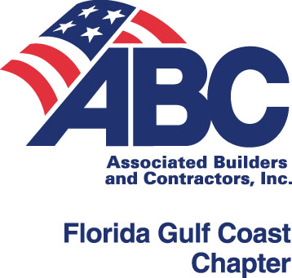
ABC APPRENTICESHIP PROGRAM
SPONSORING CONTRACTOR INFORMATION

COMPANY NAME:
PRIMARY CONTACT:
MAILING ADDRESS:
PHONE:
FAX:
EMPLOYER APPRENTICESHIP
CONTACT NAME:
CONTACT PHONE:
CONTACT CELL #:
CONTACT EMAIL:
WAGE SCALE CONTACT NAME:
EMAIL:

Thank you for completing this form. By doing so, you are assisting in updating our records regarding your apprentices.

Please return this completed form by one of the following options:

FAX: 813-876-1970
MAIL: ABC, 2008 N. Himes Avenue, Tampa, FL 33607
EMAIL: apprenticeship@abcflgulf.org

If you have any questions, please call 813-879-8064.

